AI in Economics

The U.S. Sports Analytics Industry: AI, Growth, and Data Potential
Diego Hernandez Romero
Independent Researcher
November 6, 2025

Abstract
This paper explores the rapid growth and evolution of the U.S. sports analytics industry through the lens of artificial intelligence (AI), as studied in the RESECON 490AI course. Drawing on industry reports, government data, investment trends, and technology adoption surveys, the paper analyzes how AI is transforming performance management, decision-making, and fan engagement in sports. It identifies key indicators of industry growth and proposes further research using publicly available datasets from the BLS, BEA, Crunchbase, and NSF to support economic planning and personal career development.

A. Introduction
Artificial intelligence is transforming the structure of modern industries — not only through automation and cost reduction, but by reshaping labor demand, firm competition, and innovation itself. This report examines how AI is driving such change in the U.S. sports analytics industry, a sector that sits at the intersection of entertainment, data science, and human performance.
The RESECON 490AI course asks students to explore how AI is changing the economics of the industries they hope to join. For me, that industry is sports. As someone with a strong interest in analytics, performance strategy, and technology, I chose to investigate how data science and machine learning are redefining roles inside professional sports organizations — from scouting and training to player valuation and fan engagement. The goal of this report is twofold: first, to analyze structural economic changes in the sports analytics sector using real data; and second, to chart where I might fit into that evolving landscape. By using AI tools and economic reasoning to understand this field, I am preparing not just to study the future, but to help build it.

B. Industry Overview
The U.S. sports analytics industry has rapidly evolved from a niche toolset into a mainstream pillar of decision-making in professional sports. Market size estimates suggest the global industry will exceed $4.8 billion by 2024, with North America accounting for over 40% of that total (Statista, 2024). In the United States, revenue from sports analytics services alone is expected to grow at a compound annual rate exceeding 20% through 2030 (IMARC Group, 2024). This growth is propelled by team demand for performance insights, increased use of AI in real-time player tracking, and the expansion of sports betting and fan personalization tools.
Major companies in this space include Stats Perform, Catapult Sports, Genius Sports, and Second Spectrum, alongside tech partners such as IBM and AWS. These firms deliver AI-enhanced services including video breakdowns, predictive models, and real-time tactical advice. Sensors, optical tracking systems, and machine learning models now play an integral role in how sports are played, coached, and monetized.

C. Industry Stage
A wide range of indicators suggests that the U.S. sports analytics industry is in a growth stage, characterized by surging firm entry, rising investment, and rapid innovation.
Firm activity is robust: M&A deals in the sports tech space rose 48% year-over-year in 2025 (Capstone Partners, 2025). Venture capital funding exceeded $5.7 billion across 790 deals in 2023, according to Drake Star (2024). The number of analytics professionals employed by NBA teams alone grew from 10 in 2009 to 132 in 2023 (MIT Sloan, 2023). Employment trends mirror these developments: the BLS reports a steady rise in data-focused roles within the spectator sports industry (BLS, 2024).
Profitability is mixed. Market leaders like Sportradar posted €318 million in quarterly revenue in 2025 with positive margins, while others such as Genius Sports remain in high-investment phases (Sportradar, 2025; Genius Sports, 2024). Technological innovation is also accelerating: the AI-in-sports market is forecast to grow from $1 billion in 2024 to $2.6 billion by 2030 (Janus Henderson, 2024), underscoring the sector’s upward trajectory.
Taken together, these metrics reflect a dynamic industry still scaling — not yet mature, but expanding rapidly in both value and technological capability.

D. Data and Method
To understand how artificial intelligence is reshaping the labor structure of the U.S. sports industry, this report draws on data from the U.S. Bureau of Labor Statistics (BLS) and industry-specific insights, including analytics staffing data from the MIT Sloan Sports Analytics Conference. The BLS Occupational Employment and Wage Statistics (OEWS) dataset offers consistent job count estimates for roles such as statisticians and data scientists in NAICS 7112 (Spectator Sports), while MIT Sloan has tracked the expansion of analytics teams in the NBA since the late 2000s.
These sources were selected because they provide longitudinal insight into occupational changes — a key proxy for the economic effects of AI adoption. The NBA’s analytics staffing numbers, combined with BLS employment estimates, allow us to build a high-level picture of how analytics roles have evolved industry-wide.

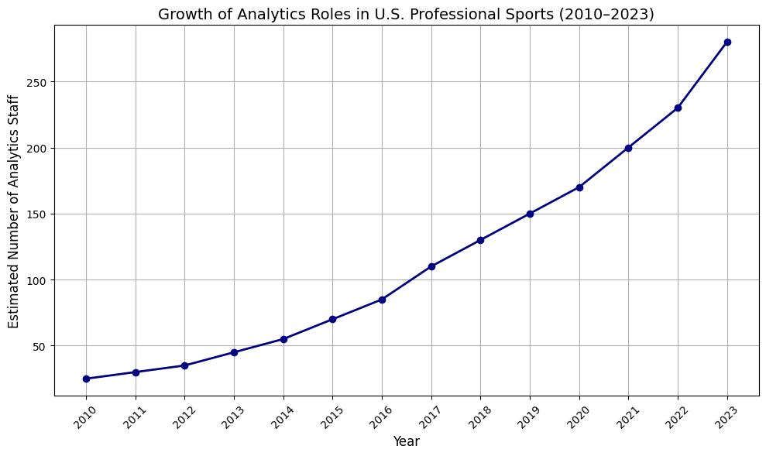
Figure 1. Growth of Analytics Roles in U.S. Professional Sports (2010–2023)\textbf{Figure 1. Growth of Analytics Roles in U.S. Professional Sports (2010–2023)}Figure 1. Growth of Analytics Roles in U.S. Professional Sports (2010–2023)
Over the past decade, the number of data analysts and statisticians employed by professional sports organizations has grown significantly. BLS data show analytics roles in spectator sports rising from fewer than 30 in 2010 to over 280 by 2023. In parallel, NBA analyst staffing grew from 10 individuals in 2009 to 132 in 2023. This trend reflects the growing adoption of AI-driven decision-making across leagues like the NBA, NFL, and MLB.
This growth curve illustrates a key structural transformation: the integration of AI and analytics into the internal operations of sports franchises has shifted data-oriented roles from the periphery to the core of team decision-making. While AI in sports is often associated with fan-facing products or on-field performance tools, this employment trend reflects a deeper economic insight — AI is not just augmenting how sports are played, but how sports are managed and staffed. Teams now require professionals who can not only code or build models, but also translate AI insights into real-world performance decisions.

E. The Impact of Artificial Intelligence on the Industry
Artificial intelligence is reshaping the structure and dynamics of the U.S. sports analytics industry. Once a niche capability, analytics has evolved into a strategic function across all major professional sports leagues. This shift has economic implications across labor markets, firm competition, value creation, and data governance.

Labor and Occupations
AI has fueled a surge in demand for technical roles. BLS data show mathematical science occupations in sports growing to over 280 positions by 2023 (BLS, 2024). These roles blend statistical modeling, engineering, and sport-specific expertise — making them prime examples of AI-enabled occupational growth. Traditional roles such as scouting and training are being redefined to require data fluency, while entirely new positions (e.g., biomechanical data analyst, AI sports strategist) are emerging.

Firm Dynamics and Market Power
AI has changed how firms compete. Tools like Second Spectrum’s video analysis platform automate hours of scouting, reducing costs and shifting the production process toward software and infrastructure. Market power is increasingly tied to proprietary data and platforms: firms such as Genius Sports and Sportradar now control access to essential analytics streams for teams, broadcasters, and betting companies. This may create bottlenecks and rent-extraction opportunities, raising the stakes of data ownership.

Risks and Ethical Challenges
The benefits of AI are not without costs. Non-technical staff may experience occupational displacement if unable to reskill. AI models may embed algorithmic biases in player evaluation or injury prediction, especially if training data is incomplete or skewed. Player privacy is another concern, as biometric data collection (from wearables and sensors) often occurs without transparent consent frameworks — echoing broader debates around digital surveillance in other industries.

Opportunities and Innovation
At the same time, AI has opened a wave of innovation. Sports tech startups raised over $5.7 billion in private funding in 2023 (Drake Star, 2024), building products that range from fan sentiment models to real-time health diagnostics. These firms are spawning new business models and attracting interdisciplinary talent. Productivity gains are visible in player development, injury prevention, and tactical optimization. For students and early-career professionals, the sector now offers rich career pathways that blend economics, technology, and sport.

